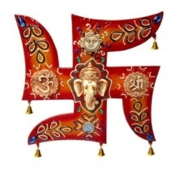 YOUR TRAVEL ADVISER!!!!!!
……………………………………………………………………………………………………………………………………………………………………………………………………
WELCOME TO DOOARS
The Dooars belonged to the Kamata Kingdom under the Koch dynasty; and taking advantage of the weakness of the Koch kingdom in subsequent times, Bhutan took possession of the Dooars. This region was controlled by the kingdom of Bhutan when the British annexed it in 1865 after the Bhutan War under the command of Captain Hedayat Ali. The area was divided into two parts: the eastern part was merged with Goalpara district in Assam and the western part was turned into a new district named Western Dooars. Again in the year 1869, the name was changed to Jalpaiguri District. After the end of the British rule in India in 1947, the Dooars acceded into the dominion of India and it merged with the Union of India shortly afterwards in 1949.
The Dooars is a large region and is dotted with many towns and cities. The largest city in the whole region stretching from the Darjeeling foothills to the Arunachal Pradeshfoothills is Siliguri. This northern Bengal city is well connected with the rest of country by road, air and railway and is the business hub of the region.
The other major cities are Kokrajhar, Bongaigaon, Goalpara, Barpeta and Dhubri in Assam. Cooch Behar, Alipurduar, Jalpaiguri, Dhupguri, Malbazar, Mainaguri and Birpara are the major cities of the Dooars in West Bengal, and Kishanganj in Bihar. Also, the commercial capital of Bhutan, Phuentsholing, near Jaigaon, can be considered a part of this region.
The beauty of the region lies not only in its tea gardens but also in the dense jungles that make up the countryside. Many wildlife sanctuaries and national park like Manas National Park in Assam, Jaldapara National Park, Buxa National Park, Gorumara National Park,Chapramari Wildlife Reserve and the Mahananda Wildlife Sanctuary in West Bengal are located in this region.
A number of rare endangered species of animals like tiger, rhinoceros and elephant make their habitat in the forests of the Dooars. Other animals includes different types of deer, bison, birds and reptiles. A railway line runs through the tea gardens and the various protected areas and a number of elephants have been killed in collisions with trains.
DAY 01 :-ARRIVAL AT NJP/BAGDOGRA & TRANSFER TO LATAGURI
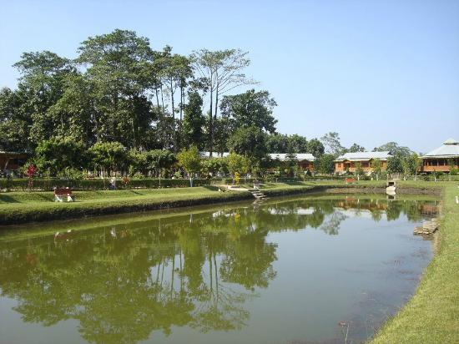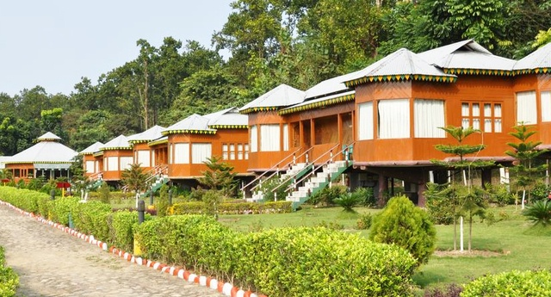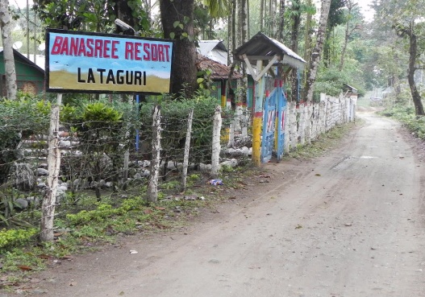
You will be greeted and assist by our official at Bagdogra Airport(IXB)/New Jalpaiguri Railway Station(NJP). He will assist you for the forwarding journey to Lataguri (100 kilometers) via sevoke Kalimandir, Coronation Bridge. Lunch on the way in Dhaba/Resort. Evening free for leisure. Night stay at Lataguri.
DAY 02 : ELEPHANT SAFARI AND EXCURSION TO JALDAPARA.
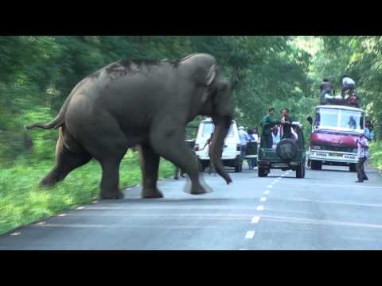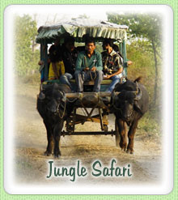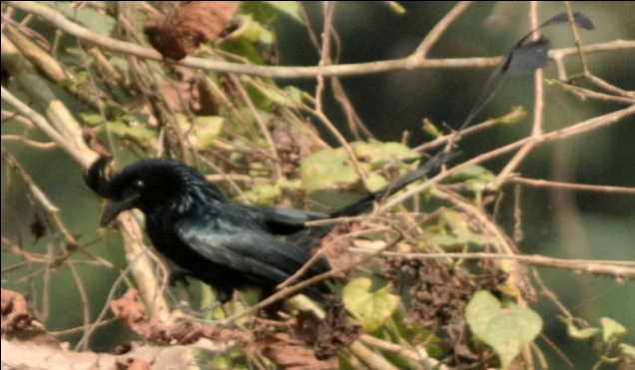
After breakfast, drive straight for an excursion to South Khayerbari animal rescue centre and Jaldapara Wildlife Sanctuary. As on 11th Jan, 2011, there are eight tigers in South Khayerbari rescue centre of which seven had been seized from different circus troupes and one was brought from Alipore Zoo. The South Khayerbari Animal Rescue Centre is also the home of 18 leopards. A leopard safari (Optional), the only one of its kind in India, can also be availed in South Khayerbari Eco Park.
Declared a wildlife sanctuary in 1991, for the protection of the Indian one-horned rhino, Jaldapara is situated in the foothills of the eastern Himalayas. The river Torsha flows through this rain forest sanctuary which is mostly covered with tall grasses. The sanctuary encompasses luxuriant vegetation and a rich variety of wildlife. The Malangi River also flows nearby from east to west. Riding elephants is the only way to move inside this forest and Visiting time is 9A.M. to 4 p.m.
The forest is mainly of Savannah Type covered with tall elephant grasses. The main attraction of the sanctuary is Asiatic one-horned rhinoceros. The sanctuary holds the highest rhino population in India after Kaziranga National Park in Assam. The other animals found are tigers, elephants, deers, sambhar, barking deer, spotted deer, hog deer, wild pig and bison. Jaldapara is a paradise for bird watchers. It is one of the very few places in India, where the Bengal Florican is sighted. The other birds to be found here are the crested eagle, Pallas's fishing eagle and shikra, besides jungle fowl, peafowl, patridges, and lesser pied hornbill. Python, monitor lizards, kraits, cobras, geckos and about 8 species of fresh water turtles have also been found in the sanctuary here.
A thrilling elephant safari is organized in the early morning from Hollong to offer the exquisite beauty of the vast grassland of Jaldapara. You can also enjoy the jeep safari (Optional) inside the sanctuary which is another main attraction. Overnight at Jaldapara Hotel/resort
DAY 03:- TRANSFER TO BAGDOGRA AIRPORT/NEW JALPAIGURI RAILWAY STATION FROM DOOARS
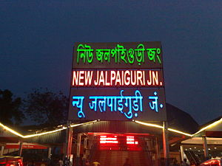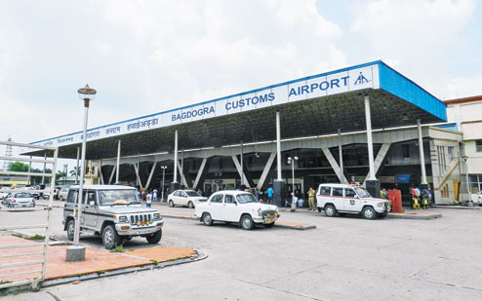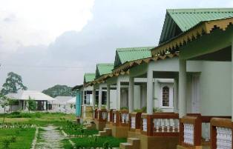
After breakfast check-out from the hotel and transfer to Bagdogra Airport(IXB) / New Jalpaiguri Railway Station (NJP) for your onwards journey.
IMPORTANT INFO:-
The Elephant Safari and Jeep Safari is booked on the spot and is subject to availability of Elephant by forest Department of Government of West Bengal and Stipulated number of entries respectively. Incase safari could not be arranged we will provide alternate safari. The forest remains closed on Thursday.
Please advise any specific dietary requirements at the time of booking.
- Passport Name, Number,Expiry and country is required at the time of booking for International guests.
- Carry all your documents and money.
INCLUSION
- 3 NIGHTS ACCOMODATION IN 5 STAR,4 STAR, 3 STAR, DELUX & STANDARD HOTELS
- TRANSFER ALL IN PRIVATE IN 4 SEATER (WAGONR/SANTRO),7 SEATER (INNOVA /XYLO), 8 SEATER (BOLERO/TAVERA/SCORPIO/TATA SUMO)
- SIGHT SEEN AS PER ITINERARY
- DRIVER CUM GUIDE
- PICK UP AND DROP FROM BAGDOGRA AIRPORT(IXB) / NEW JALPAIGURI RAILWAY STATION(NJP)
- FOOD AS PER CP(BREAKFAST ONLY)
- VEHICLE WILL BE PROVIDEDPOINT TO POINT AND NOT AT DISPOSAL
EXCLUSIONS
- Extras of personal nature such as personal tips, laundry charges, additional tour charges.
- Does not include any Lunch, Evening Tea/snacks & dinner
- Insurance, Medical & Emergency rescue costs.
- Does not include Hard DRINKS OR liquor or mineral water or soft drinks/juices.
- Does not include Entrance Fees at Monasteries / Monuments / Museums etc.
- Does not include specialized Guide
- AIR FARE / TRAIN FARE
- ANY OTHER ITEMS NOT MENTIONED IN COST INCLUDES
HOW TO BOOK
Just pay 25 % of the package cost inclusive of taxes and full amount of the airlines cost. You will get a booking confirmation voucher within 240 minutes of the payment receipt and your booking status will be "BOOKING HOLD- CONFIRMED"
- Please do not forget to send one email to rstravels86@gmail.com
post payment mentioning your reference number. If you do not get voucher on-time you may call us at +91-8768841510

BANK ACCOUNT DETAILS

ACCOUNT HOLDER NAME :- R S TRAVELS
BANK NAME:-UNION BANK OF INDIA
ACCOUNT NO :- 702101010050095
IFS CODE :-UBIN0570214
ACCOUNT TYPE :- CURRENT A/C
BRANCH NAME :- JAIGAON

ACCOUNT HOLDER NAME :- R S TRAVELS
BANK NAME:-STATE BANK OF INDIA
ACCOUNT NO :- 35081943112
IFS CODE :-SBIN0006278
ACCOUNT TYPE :- CURRENT A/C
BRANCH NAME :- JAIGAON
PAYMENTS TERM

- 25 % at the time of booking and balance 10 days prior travel date.
- No booking are guaranteed without advance payment and rates are subject to availability.

CANCELLATION POLICY

- Less than 7 days prior to Date of Travel: 100% of the package cost as cancellation charge.
- 7-15 days prior to Date of Travel: 75% of the package cost as cancellation charge.
- 16-30 days prior to Date of Travel: 50 % of package cost as cancellation charge.
- More than 30 days: Full refund of package cost excluding processing fees.
TERMS AND CONDITIONS

- R.S travels reserves the right to re- arrange itinerary to suit hotel availability without changing the hotel number of days in each destination and without compromising any services.
- The vehicle used is Ac or Non Ac and is available for point to point services only and is not at disposal. Clients are requested to follow the itinerary.

CHILD POLICY

- Children above 10 + years will be charged 100 % as per adult rate.
- Children of age 5 to 10 years will be charged 50 % of adult.
- Children below 5 years as a complimentary

